S/No | Equipment & Instrument | Number required | Specifications
 | Non Recurring Heads
1 | Cryo gun | 1 | - The cryotips shall be rounded in shape and should be (19+/-2) mm in diameter  - The surface that contacts the tissue should be either flat or with a cone extrusion ( nipple shaped), not exceeding 5 mm (conical cryotips with extended nipple lengths shall not be used for treating precancerous cervical lesions)
 | 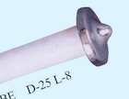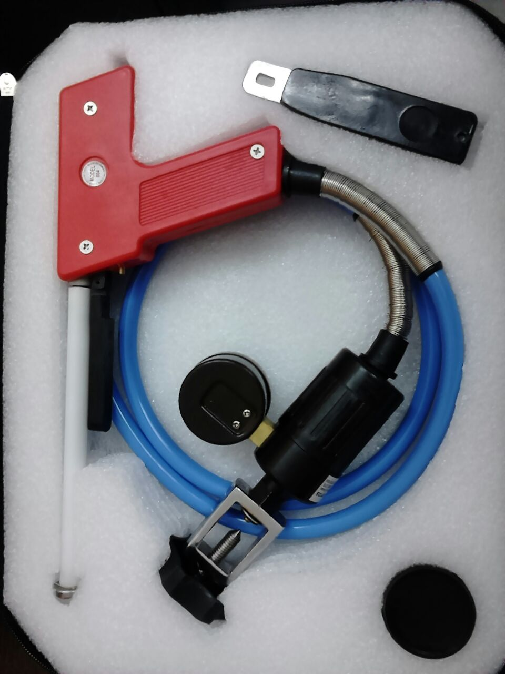
Annexure-3
List of CaCx Materials for Procurement with Specifications
List of Materials for Procurement with Specifications…….contd

2 | Cylinder for Cryo gun | 3 | Nitrous oxide (‘A’ size cylinder)
 | 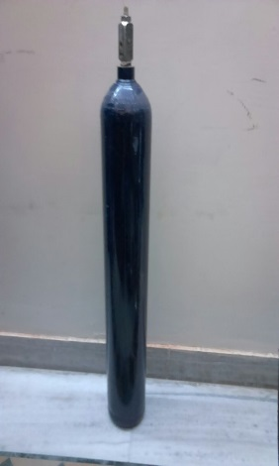
3 | Cusco’s Speculum | 23(in total) | Flat blades, Large size – 5, Medium size– 15, Small size – 3
 | 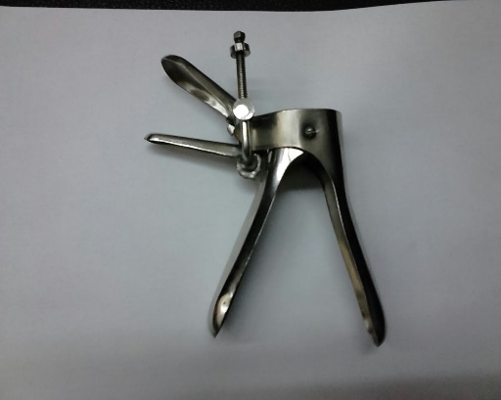
4 | Sponge Holder | 23 | 8 inches
 | 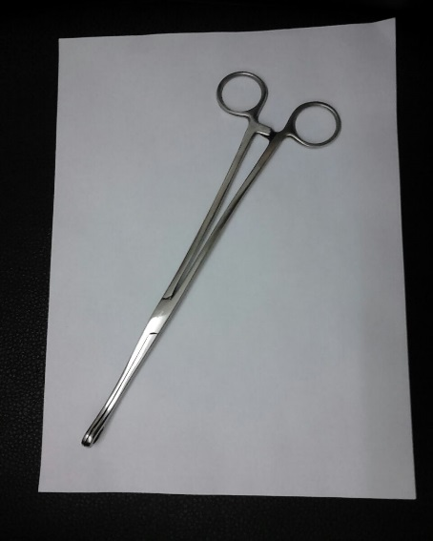
5 | Torch (with halogen light)/halogen lamp | 1 | Standard size
6 | Focus Light source (white light) | 1
6 | Cheatle’s forceps ‘ | 1 | Standard size
7 | Instrument Tray & Drum | 2 each | Drum - 12 inches height 12 inch diameter, Tray – Stainless steel tray with lid for instrument set, large size.
8 | BP Instrument | 1 | Digital good quality BP Instrument
9 | Measuring Plastic cylinder /50 ml, 5 ml syringe. | 2-2 each | 100 ml capacity, Plastic Material
 | 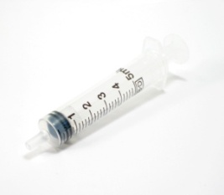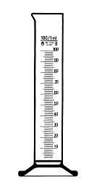
10 | Glass Jars | 2 | 9 cm height ,6 cm mouth (Below given photograph)
11 | Bowl (Stainless steel) | 2 | Standard size stainless steel bowl
12 | Mackintosh/Rubber Sheet /Kelly’s pad | 2 | Standard size for examination table.
13 | Gynae. Examination table with mattress | 1 | Standard dimensions (optional)
14 | Cylinder stand | 1 | According to the size of cylinder
15 | Glucometer | 1
16 | Hemoglobinometer | 1
18. | Measuring tape | 1
19. | Stadiometer | 1
 | Recurring Heads
A | Glacial Acetic Acid |  | --------
B | Normal Saline |  | --------
C | Distilled water |  | --------
D | Liquid Soap |  | --------
E | Gloves |  | Disposable, clean, new
F | Bleaching powder |  | -----------
G | IP Kit For preparation of bleaching solution (Two tubs,1 one liter mug ,I small plastic bowl, utility gloves - 1 pair, 1 Teaspoon) |  | -----------
H | Cotton roll |  | Big bundle
I | Cotton tipped swabs |  | To be made at the centre
J | Glucometer strips
K | Hemoglobinometerstrips
L | Spirit swab
 | 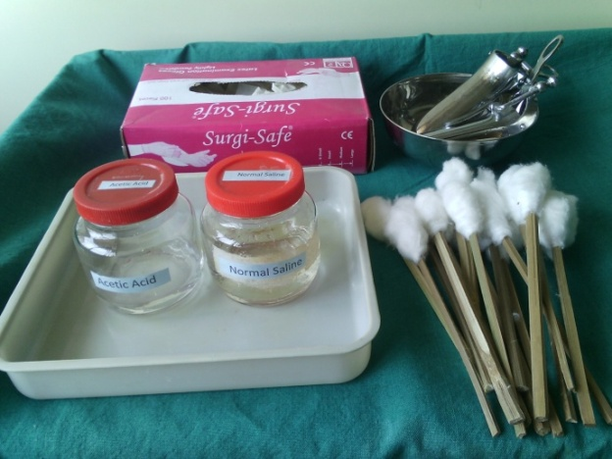
 | -----------------x---------------

